#include <stdio.h>
#include "glut.h"
#include <math.h> // Needed for cosf, sinf

void DrawCoodinate()//vẽ hệ trục tọa độ xy
{
//Vẽ trục x - màu xanh lá
glColor3f(0.0, 1.0, 0.0);
glBegin(GL_LINES);
glVertex3f(-1.0, 0.0, 0.0);
glVertex3f(1.0, 0.0, 0.0);
glEnd();

//Vẽ trục y - màu đỏ
glColor3f(1.0, 0.0, 0.0);
glBegin(GL_LINES);
glVertex3f(0.0, -1.0, 0.0);
glVertex3f(0.0, 1.0, 0.0);
glEnd();
}

// --- Inserted DrawBookshelf function here ---
void DrawBookshelf()
{
// Draw bookshelf background (brown)
glColor3f(0.9f, 0.4f, 0.2f);
glBegin(GL_POLYGON);
glVertex2f(-0.7f, -0.7f);
glVertex2f(0.7f, -0.7f);
glVertex2f(0.7f, 0.7f);
glVertex2f(-0.7f, 0.7f);
glEnd();

// Draw bookshelf border (darker brown)
glColor3f(0.4f, 0.2f, 0.05f);
glLineWidth(8.0f);
glBegin(GL_LINE_LOOP);
glVertex2f(-0.7f, -0.7f);
glVertex2f(0.7f, -0.7f);
glVertex2f(0.7f, 0.7f);
glVertex2f(-0.7f, 0.7f);
glEnd();

// Draw three horizontal shelves
glColor3f(0.4f, 0.2f, 0.05f);
glLineWidth(4.0f);
glBegin(GL_LINES);
glVertex2f(-0.7f, 0.25f); glVertex2f(0.7f, 0.25f);
glVertex2f(-0.7f, -0.15f); glVertex2f(0.7f, -0.15f);
glVertex2f(-0.7f, -0.55f); glVertex2f(0.7f, -0.55f);
glEnd();

// Draw blue circle (top left)
glColor3f(0.4f, 0.8f, 1.0f);
float cx = -0.45f, cy = 0.33f, r = 0.07f;
glBegin(GL_POLYGON);
for (int i = 0; i < 40; ++i) {
float theta = 2.0f * 3.1415926f * float(i) / 40.0f;
glVertex2f(cx + r * cosf(theta), cy + r * sinf(theta));
}
glEnd();

// Draw pink triangle (top center)
glColor3f(1.0f, 0.6f, 0.9f);
glBegin(GL_TRIANGLES);
glVertex2f(0.0f, 0.55f);
glVertex2f(0.12f, 0.38f);
glVertex2f(-0.12f, 0.38f);
glEnd();

// Draw three vertical green books (bottom left)
glColor3f(0.3f, 1.0f, 0.5f);
float bx = -0.55f, by = -0.15f, bw = 0.05f, bh = 0.25f;
for (int i = 0; i < 3; ++i) {
glBegin(GL_POLYGON);
glVertex2f(bx + i * 0.1f, by);
glVertex2f(bx + i * 0.1f + bw, by);
glVertex2f(bx + i * 0.1f + bw, by + bh);
glVertex2f(bx + i * 0.1f, by + bh);
glEnd();
}

// Draw slanted green book (bottom left)
glPushMatrix();
glTranslatef(0.35f, -0.55f, 0.0f);
glRotatef(-35, 0, 0, 1);
glBegin(GL_POLYGON);
glVertex2f(-0.025f, 0.0f);
glVertex2f(0.025f, 0.0f);
glVertex2f(0.025f, 0.18f);
glVertex2f(-0.025f, 0.18f);
glEnd();
glPopMatrix();

// Draw slanted green book (middle right)
glPushMatrix();
glTranslatef(0.45f, 0.15f, 0.0f);
glRotatef(25, 0, 0, 1);
glBegin(GL_POLYGON);
glVertex2f(-0.025f, 0.0f);
glVertex2f(0.025f, 0.0f);
glVertex2f(0.025f, 0.28f);
glVertex2f(-0.025f, 0.28f);
glEnd();
glPopMatrix();
}

void RenderScene()
{
glClear(GL_COLOR_BUFFER_BIT);
glLoadIdentity();
DrawCoodinate(); // Draw coordinate axes

// Draw the bookshelf
DrawBookshelf();

// Save the current coordinate system
glPushMatrix();

// Translate the coordinate system
glTranslatef(0.2, 0.0, 0.0);

// Rotate the coordinate system (e.g., -30 degrees for clockwise rotation)
glRotatef(-30, 0.0, 0.0, 1.0);

// Scale the coordinate system
glScalef(0.5, 0.5, 0.5);

// (Polygon drawing code removed)

// Restore the previous coordinate system
glPopMatrix();

glutSwapBuffers();
glFlush();
}

void init(void)
{
glClearColor(1.0, 1.0, 1.0, 1.0); /* nền đen */
glOrtho(-1.0, 1.0, -1.0, 1.0, -1.0, 1.0);
}

void main()
{
glutInitDisplayMode(GLUT_DOUBLE | GLUT_RGB);
glutInitWindowSize(640, 480);
glutInitWindowPosition(100, 100);
glutCreateWindow("Translate");
init();
glutDisplayFunc(RenderScene);
glutMainLoop();
}
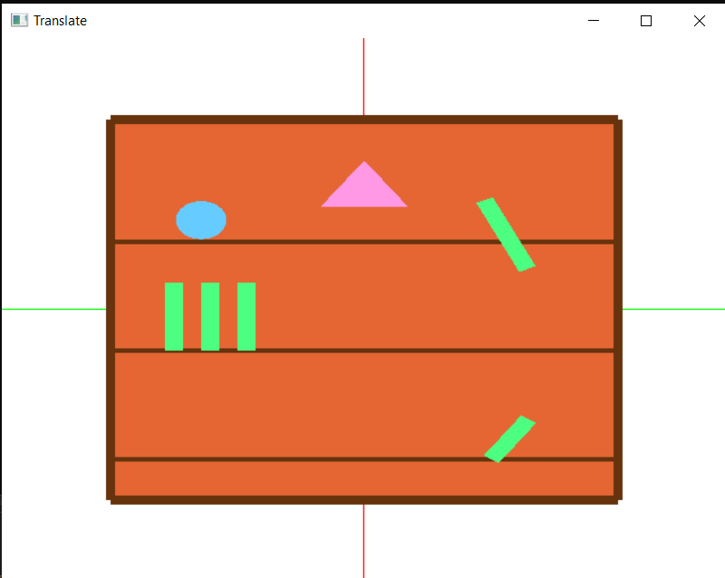
MAI VĂN ĐẠT
LỚP : DCCNTT13.10.6
MSV : 20220966

